WareHouse Management System Using LORA-ESP32

1. Sender Door LORA Devices.JPG: Sender.ino

2. Receiver Door LORA Device.JPG : Receiver.ino

Web Map :
Note: Place the web Files in same Folder and Paste the content as it is…
Door.csv : Door Num, GPS Lang, GPS Lati, Status

CSVmap.php

Map7.html

WebApp Working:

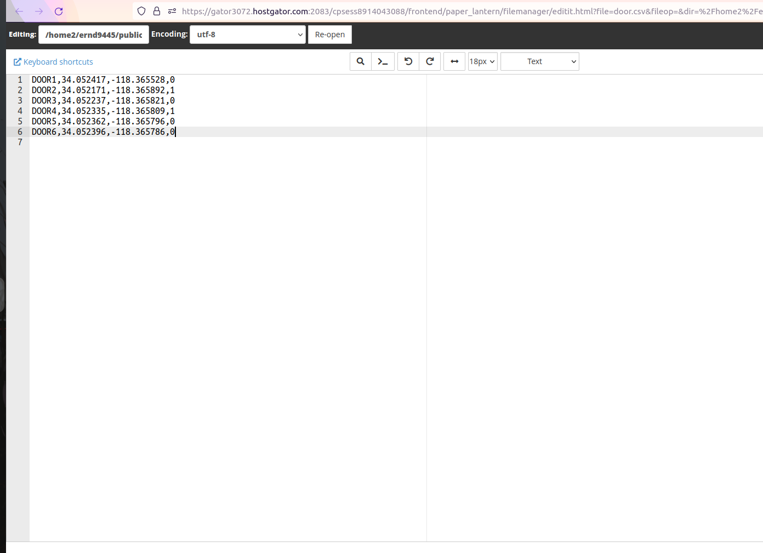

The Web Map will show mark according to the csv file if the status is 1 it will mark location on map if 0 then it will disappear from map.
Map Checks csv every 10 sec. Esp32 updates csv every 30 sec.
